SUTHERLAND ZONE CROSS COUNTRY HEATHCOTE HIGH SCHOOL 2019
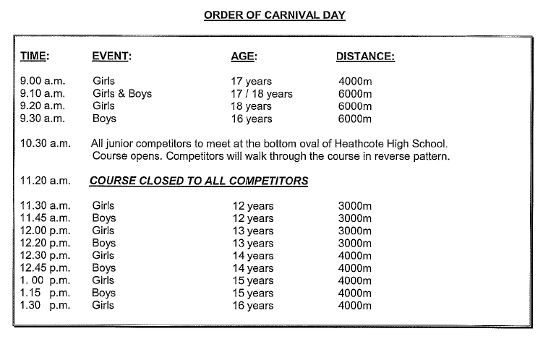
STAFF ON TRACK DUTY STAY ON POINTS FOR DURATION OF THE CARNIVAL. INDIVIDUAL SCHOOLS CAN RELIEVE STAFF ON TRACK WITH THEIR FLOATING TEACHER.
POSITIONS 2 to 6 WILL HAVE NOT STUDENTS RUNNING ON TRACK FROM 10.30AM TO 12.15PM.
FIRST AID OFFICER WILL BE LOCATED NEAR THE RECODING AREA AT HEATHCOTE HIGH.
MOBILE STUDENT FIRST AID OFFICERS ARE ON TRACK FOR THE DURATION OF ALL EVENTS.
HEATHCOTE HIGH CANTEEN IS AVAILABLE THROUGHOUT THE DAY FOR ALL SCHOOL AND STAFF.
ENJOY YOUR DAY.

SUTHERLAND ZONE CROSS COUNTRY 3KM TRACK 2019

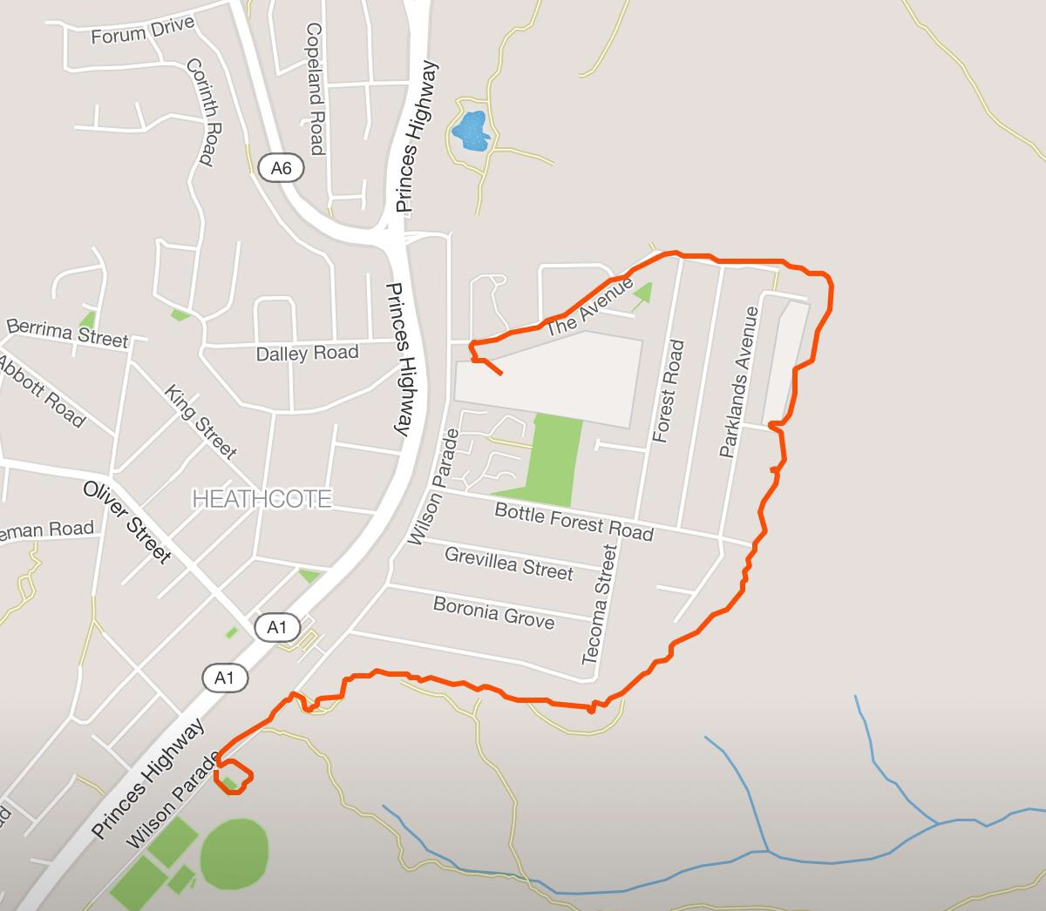

12 Years Girls | 12 Years Boys | 13 Years Girls | 13 Years Boys
All junior competitors will walk the track in reserve pattern at 10.30am from HHS
STARTING POINT FOR 3KM IS HEATHCOTE OVAL,
FINISHING POINT IS HEATHCOTE HIGH

SUTHERLAND ZONE CROSS COUNTRY 4KM TRACK 2019
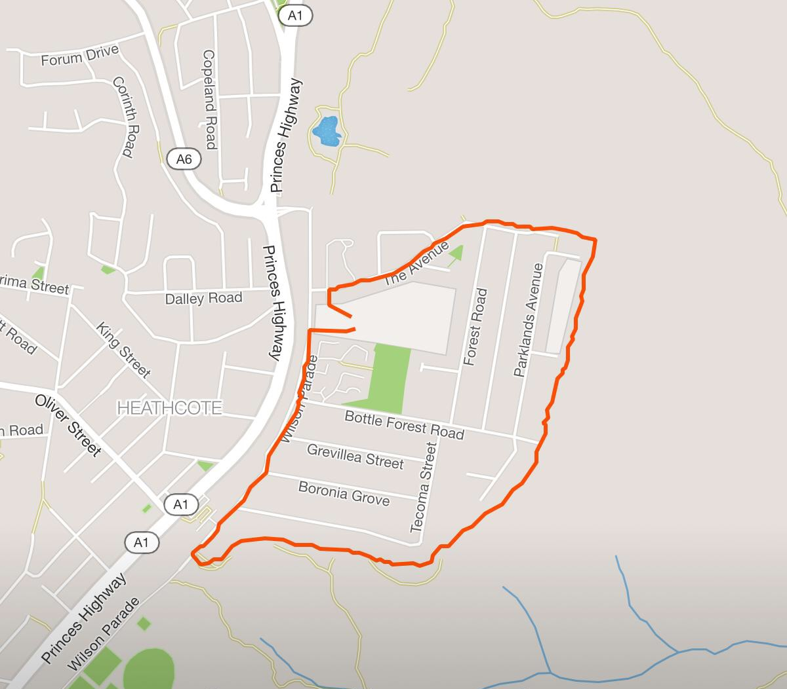

14 Years Girls | 14 Years Boys | 15 Years Girls | 15 Years Boys
16 Years Girls | 17 Years Girls
All students will start and finish the 4km from HHS.
STARTING & FINISHING POINT FOR 4KM IS HEATHCOTE HIGH

SUTHERLAND ZONE CROSS COUNTRY 6KM TRACK 2019

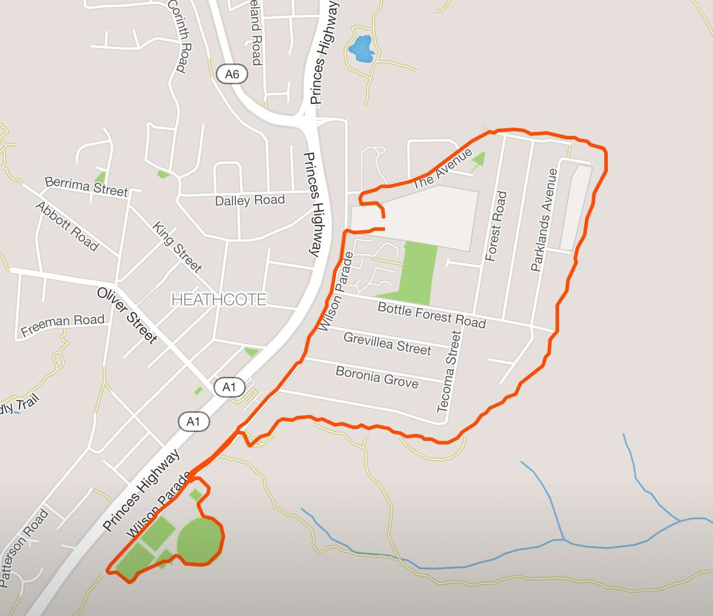
16 Years Boys | 17 Years Boys | 18 Years Boys | 18 Years Girls

Students running the 6km track will need to run an extra loop around the Heathcote Oval complex before heading into the National Park track.
STARTING & FINISHING POINT FOR 6 KM IS HEATHCOTE HIGH

